INTRODUCTION TO PROGRAMMING

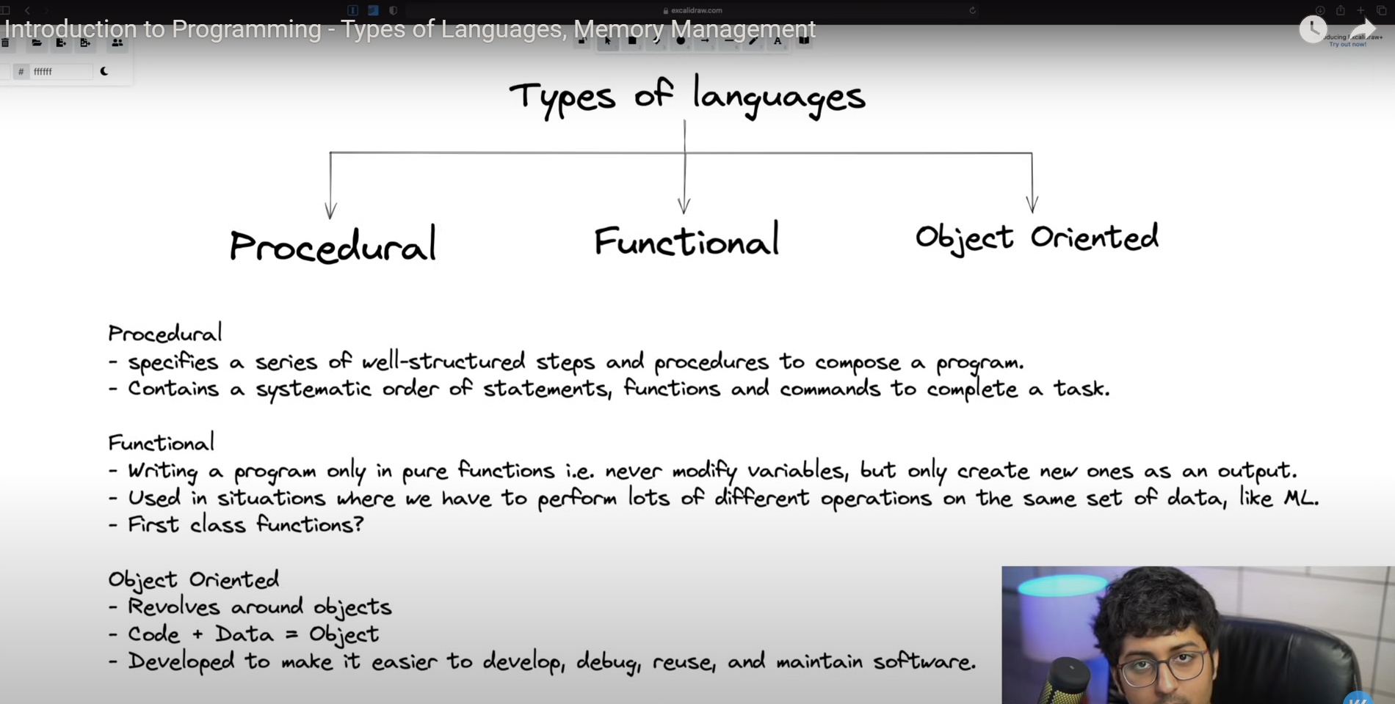

Static vs Dynamic Languages

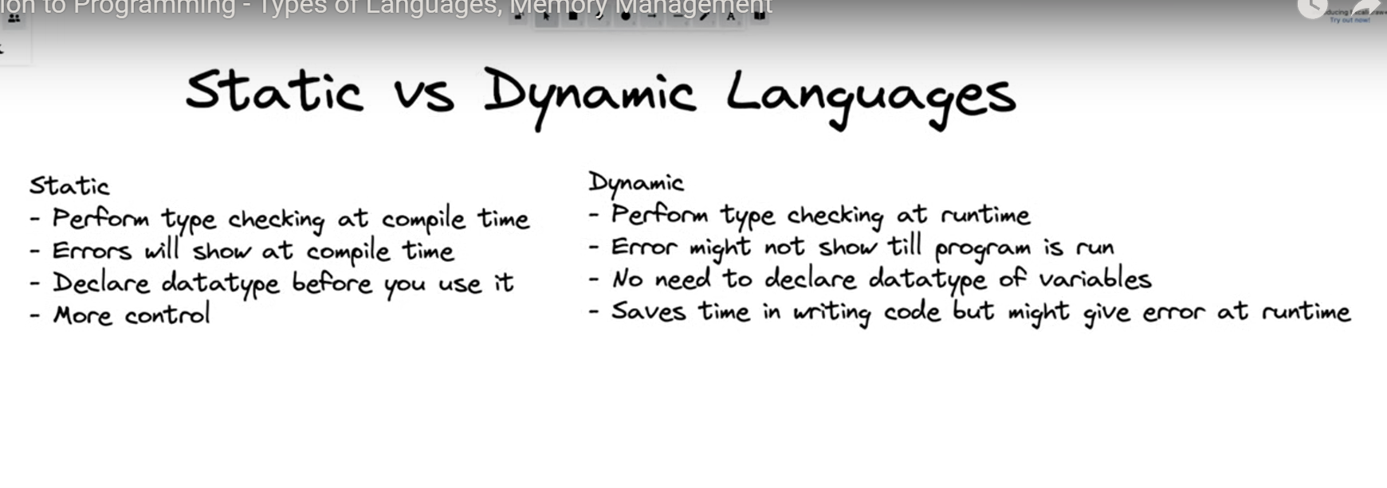

Static Languages = C++, Java

Dynamic = Python, JavaScript

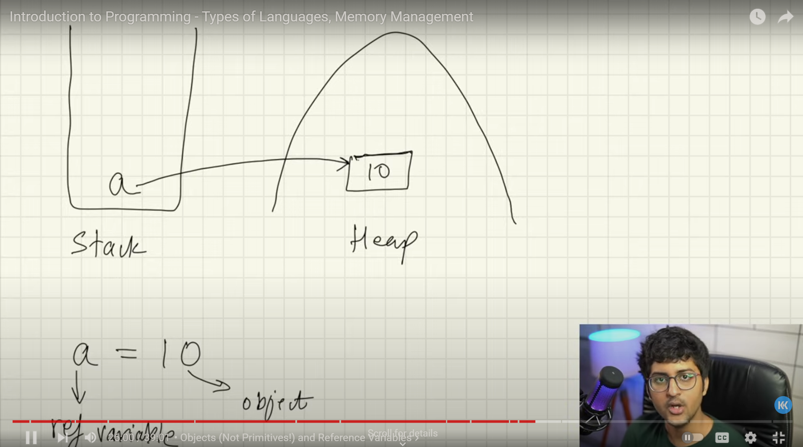

Variables in stack memory and pointing towards to the heap memory

String name = “Shubham”

In these example name is reference to the object so name is stored in the stack memory and value is stored in the heap memory

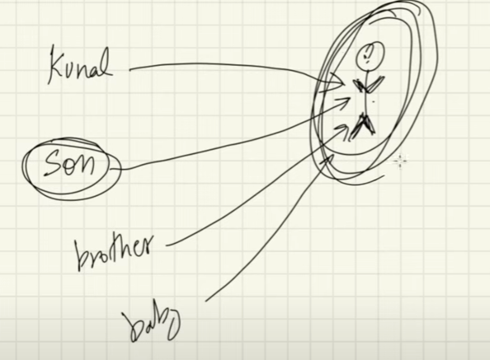

More than one ref variables points to the object

If any one of the object changes the object then it changes original objects

What is garbage Collection in Java?

* Object who do not have reference variables pointing towards object
* In that case it removes from the memory

FLOWCHARTS

